You have been hired to review the landscape of apps on the Shopify platform, using data scraped from publicly available Shopify websites. You want to figure out what key factors play into the success of a Shopify app.

Q1 Make a Scatterplot with the reviews_count on the X axis and the average rating on the Y axis. Annotate your interpretation of this with an inserted Text Box next to this scatterplot.
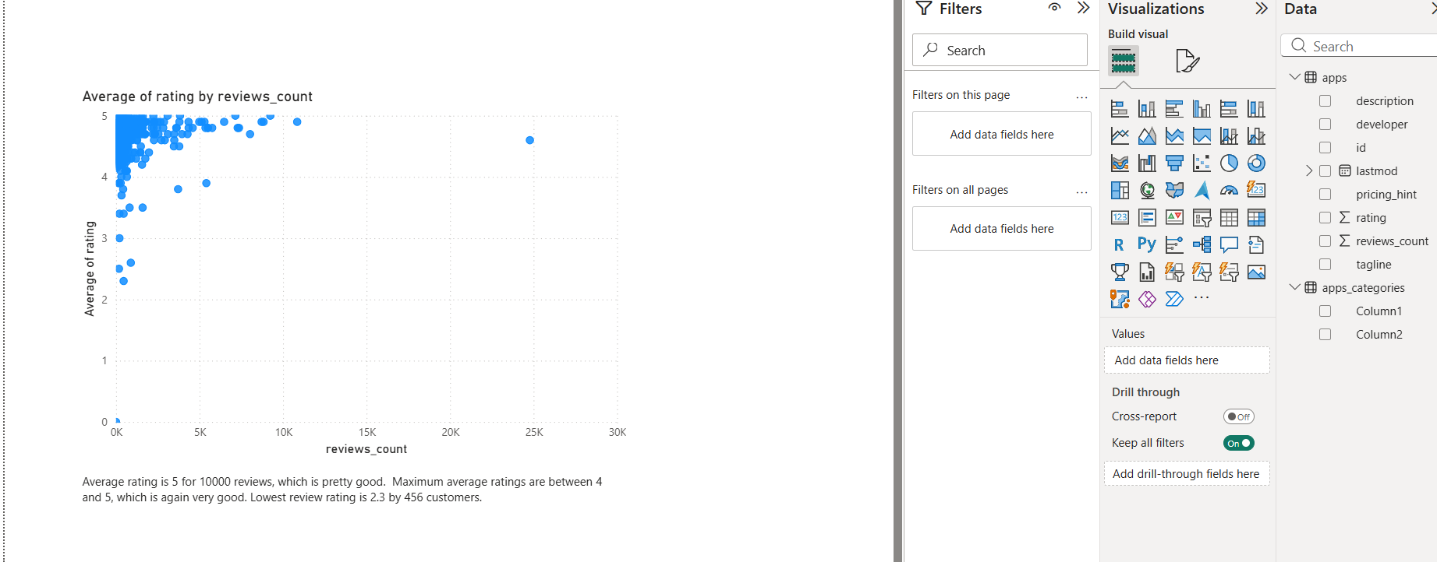

- Q2. Using this new table, make a bar chart with the developer on the X-Axis, and the sum of rating on the Y-Axis..
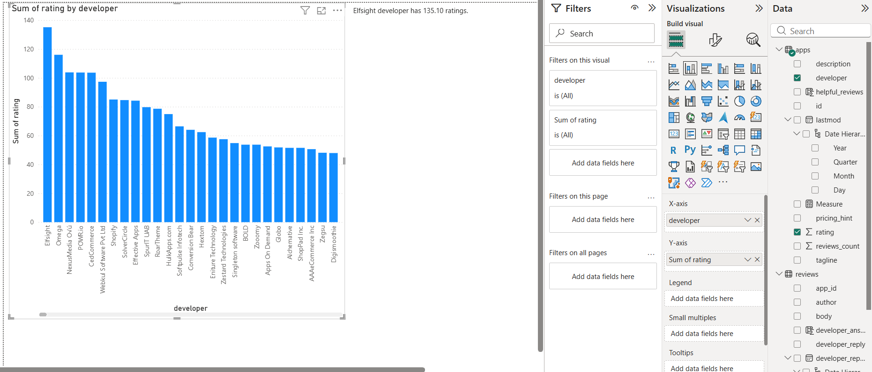

Q3. The chart in the previous question is misleading because an app could have a high sum of rating because it has many one-star reviews. Make a new bar chart with developer on the X-Axis against the helpful_review average on the Y-Axis.

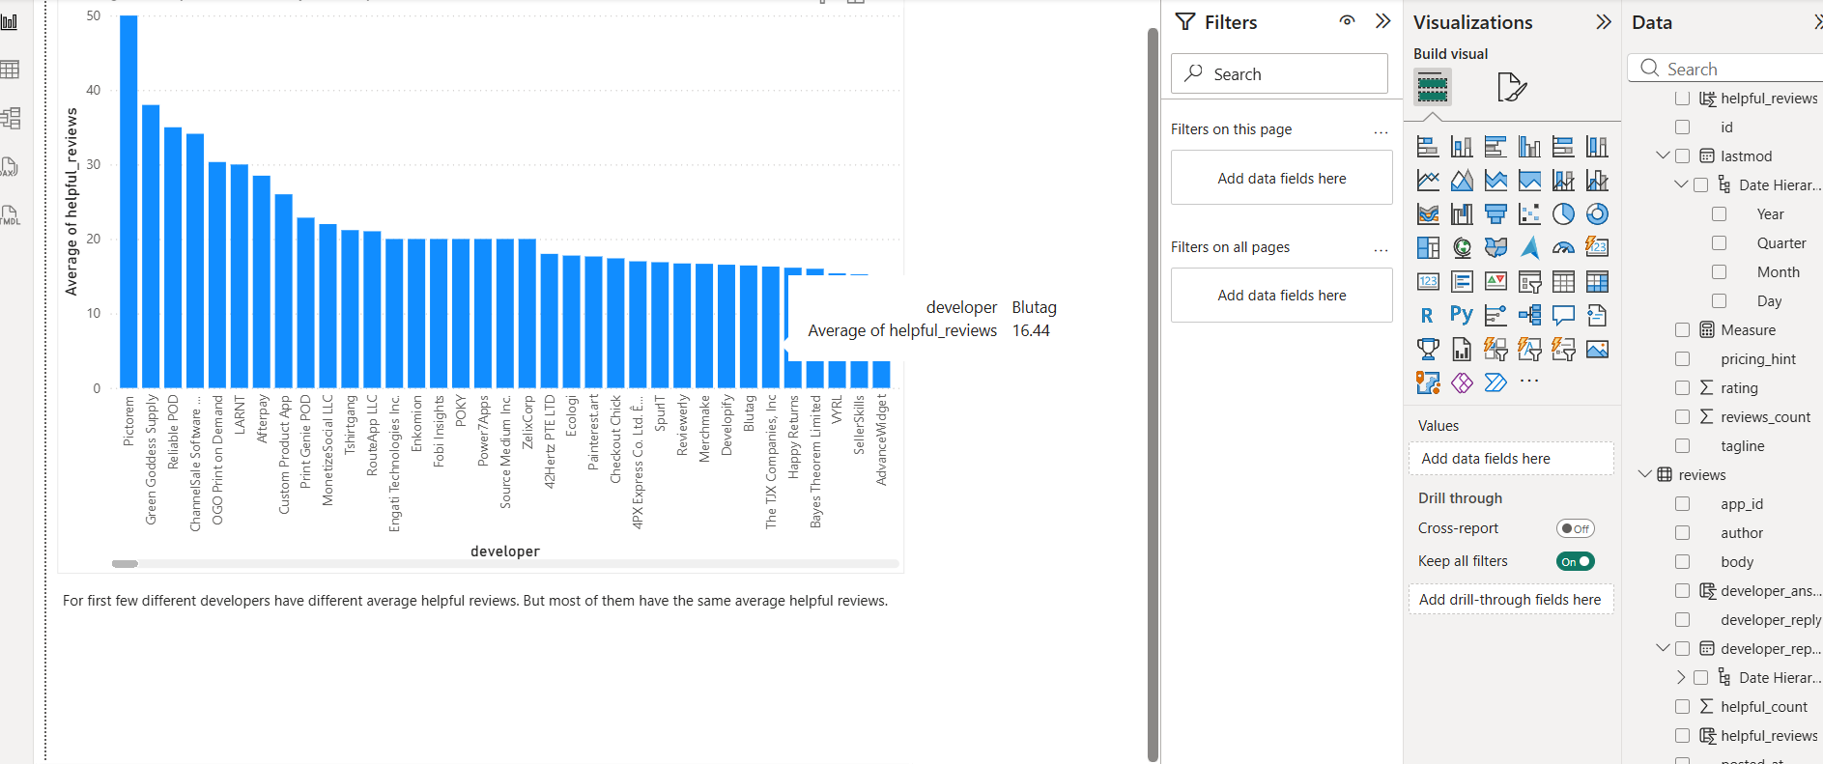
Q4. Which developers are the most responsive? Make a bar chart with the developer from the apps table and the developer_answered column you created in question 2.2. Add a Filter for this visual only which selects only the rows where reviews_count is greater than 500.
